

**SCHOOL OF ENGINEERING & TECHNOLOGY**

**BSC (HONS) IN COMPUTER SCIENCE**

**CSC2014 - Digital Image Processing**

**Group Assignment**

| *Prepared by:* | *Prepared for:* |
| --- | --- |
| Mohammed Moatasem Faisal  Al-Attraqchi – 22043657 | Dr Chia Wai Chong |
| Marvin Raj – 22090120 |  |
| Ryan Che Hernandez – 22042964 |  |
| Shayne Lim Yi Xuan – 21012125 |  |

December 18, 2023

**1.0 INTRODUCTION**

This report details the methodologies and outcomes of two distinct tasks related to image and video processing, utilizing techniques from the field of computer vision, particularly leveraging OpenCV, a powerful library in Python. The primary goal of these tasks is to automate certain aspects of video and image processing, which are increasingly vital in digital content creation and data analysis. The report is structured to provide a comprehensive understanding of the processes involved, the challenges encountered, and the solutions implemented.

In Task A, which revolves around YouTube video processing, we focus on enhancing YouTube videos through brightness adjustment, face blurring, video overlaying, watermarking, and end-screen addition. The report explains each feature's implementation, emphasizing automated processing with minimal manual input.

Whereas Task B deals with extracting and sorting paragraphs from formatted scientific papers converted to images. It highlights the use of histogram projection and contour analysis for efficient text data extraction from variously formatted images.

The report offers a concise overview of these tasks, detailing methodologies, discussions, and results.

**2.0 TASK A – YOUTUBE VIDEO PROCESSING**

The code works in series layout meaning the output from the first function is taken as an input for the function that follows it.

**2.1 Methodology Process**

1. Input video path and optional parameters, determine if the video is day or night and brighten the video if necessary.
2. Apply face detection and gaussian blur, then it writes the processed frames to a new video file.
3. Accept 2 video paths as input, resize and overlay the second video onto the first, draw a border and write the frames to a new file.
4. Take a video path as input, alternate between two watermarks, add the current watermark to each frame, and write the frames to a new video file.
5. Input two video paths, write frames from the main video, then write frames from the endscreen video, creating a new video file with both.
6. A for loop to call the functions and run them in a series.

**2.2.1 Results and discussion for day_night_checker().**

The day_night_checker() function is designed to analyze video frames to assess overall brightness. This assessment is used to determine if a video was shot during day or night and then update the isDay boolean value. The function operates on the principles of video frame analysis, grayscale conversion, and average brightness calculation.

*Grayscale Conversion & Average Brightness Determination:*

The initial for loop, located within the day_night_checker function, is fundamental for analyzing the brightness characteristics of each frame in the given video. By employing OpenCV, the loop reads frames, converts them to grayscale using ‘cv2.cvtColor’, and calculates the average brightness through NumPy's ‘np.mean’. The cumulative brightness values provide insights into the overall illumination of the video.

*Day/Night Threshold Comparison and Global ‘is_day’ Flag:*

Within the day_night_checker() function, ‘threshold_brightness’ is employed to discern between day and night recordings, predicated on the average brightness of video frames. If the average brightness falls beneath this set threshold (100), the function identifies the video as captured at night. This threshold assessment plays a pivotal role in dictating subsequent video processing steps. Simultaneously, a global boolean variable, is_day, serves as a flag to convey the day/night status. It indicates whether additional brightness adjustment is required. Additionally, is_day impacts the output path for the processed video. Nighttime images are saved with "brightened_" + video_path, while daytime images follow the original video path. The brightness of each frame is enhanced using the ‘cv2.convertScaleAbs’ function. This function scales the pixel values of the frame, increasing the brightness. The alpha parameter controls the scaling factor, and in this case, it is set to brightness_factor. The beta parameter is set to 0, indicating no additional bias. We chose to convert the scale over adding to prioritize pixel value integrity, data type preservation, and code clarity within the context of image processing.

*Sample Video Output –*

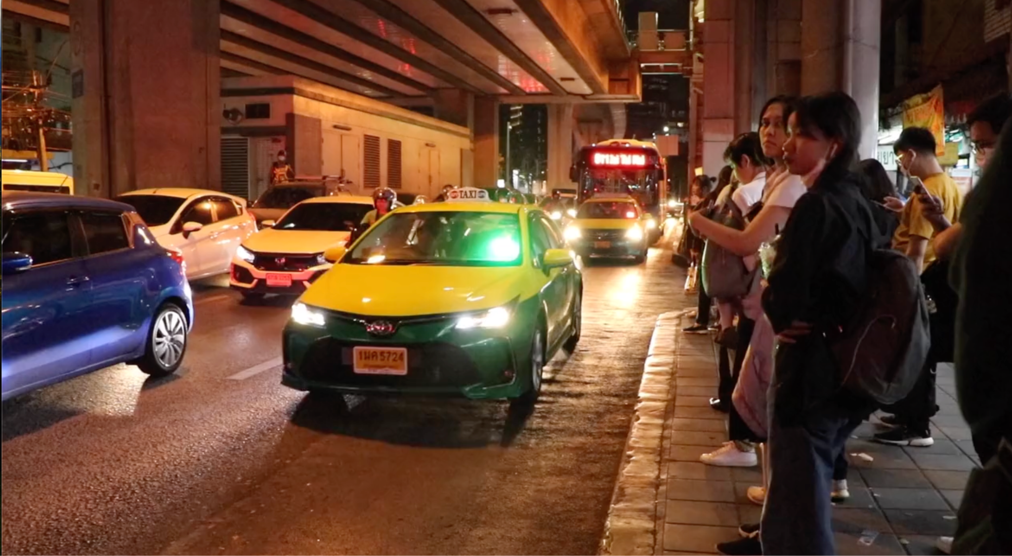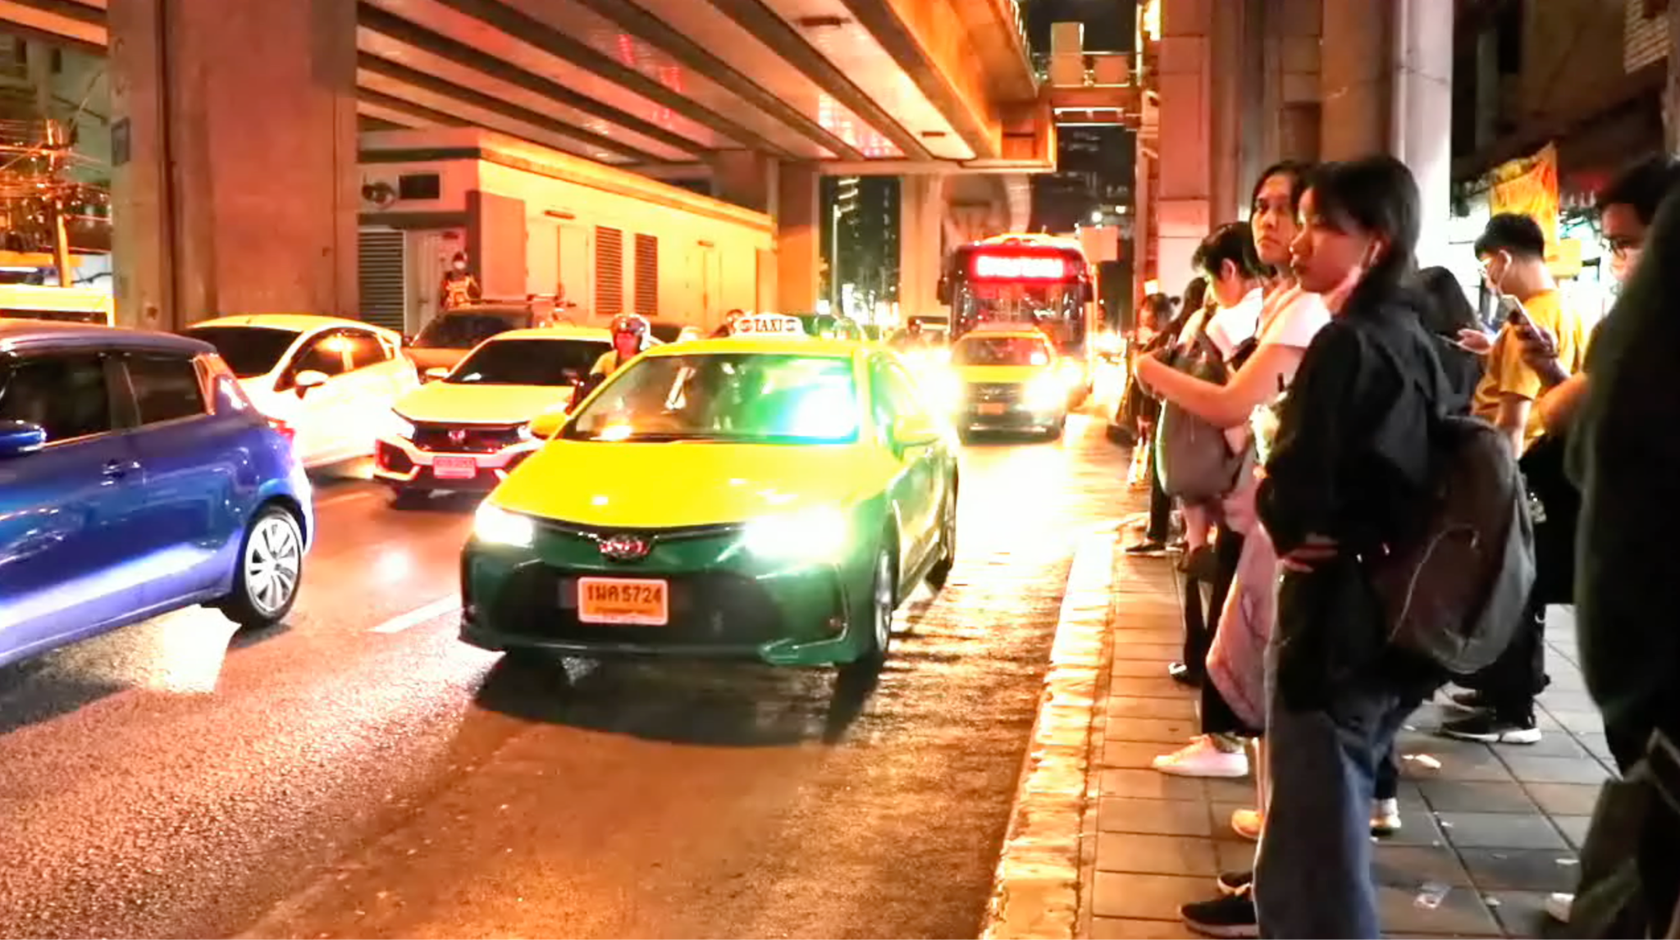

*Figure 5: Video before brightening* *Figure 6: Video after brightening*

***2.2.2 Results and discussion for blur_video()***

The “blur_video” function is designed to process video frames by identifying human faces and applying a Gaussian blur to these areas. This function serves to anonymize individuals in the video, maintaining privacy while keeping the rest of the scene visible.

*Face Detection Cascade:*

Face detection mechanisms are conducted by using the Haar Cascade Classifier that utilizes the ‘face_detector.xml’ package. This classifier is adept at recognizing human faces within video frames.

*Face Detection Mechanism:*

Next, a for loop is used to iterate through each frame and resizes that frame to 1280x720, the resizing helps to standardize the resolution which ensures consistency throughout the video processing. This is important in case the input video is in different size or aspect ratio. Also, processing the video at a lower resolution reduces the computational load and improves the speed of the face detection algorithm.

After that the brightness of the frame is increased by 10 with the help of cv2.add function. This makes it easier to detect faces in frames that are originally dark or underexposed. In addition, adjusting the brightness helps to help standardize the lighting conditions across different frames, which can be beneficial for the consistency of face detection.

The frame is then converted to grayscale because the face detection algorithm does not require color information. By doing so, the algorithm processes one channel instead of three. Reducing computational complexity. In addition, Grayscale images luminance (light intensity), which is more relevant for detecting structural features like those used in face detection.

The detectMultiScale function is a part of OpenCV's Haar Cascade Classifier, an effective method for object detection. It scans the image for features that match pre-defined face patterns.

To conclude the parent for loop with ‘faces.detectMultiScale()’. The function parameters, such as scaleFactor and minNeighbors, allow the algorithm to adjust the scale of detection and sensitivity, respectively. A scaleFactor of 1.3 means the algorithm scales down the image size by 30% each time it scans for faces, while minNeighbors defines how many neighbors each candidate rectangle should have to retain it.

A child loop is used to iterate over each detected face in the frame. The ‘detections’ variable contains a list of rectangles, each represented by ‘(x, y, w, h)’. ‘x’ and ‘y’ are the coordinates of the top-left corner of the rectangle. ‘w’ (width) and ‘h’ (height) specify the dimensions of the rectangle. Next, the ‘cv2.GaussianBlur’ function blurs the pixels within each face's bounding rectangle, using a 15x15 kernel. This specific choice of kernel size ensures a sufficient blurring effect to anonymize the faces without affecting the clarity of the rest of the frame.

*Sample Video Output –*

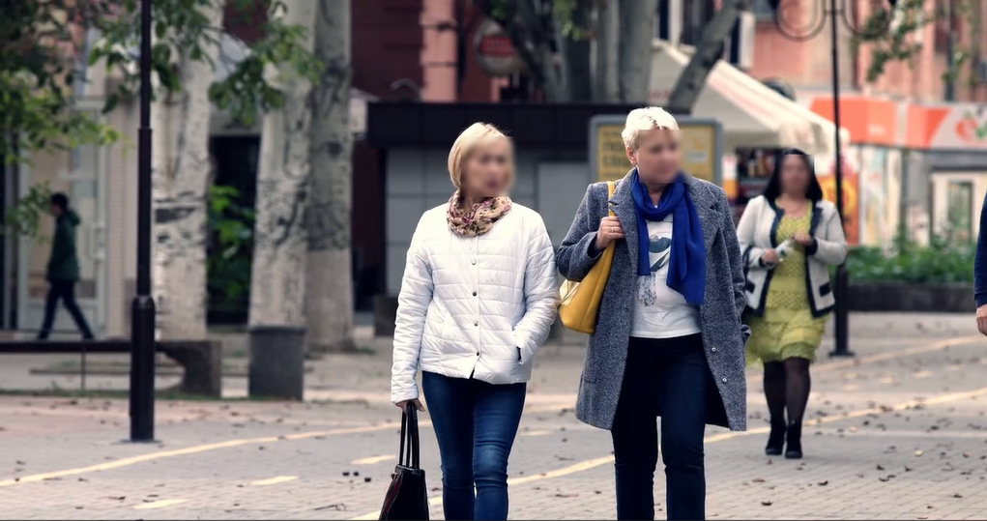

*Figure 8: Sample video output after blurring face*

***2.2.3 Results and discussion for overlay_video()***

The overlay_video function merges two input videos, video1 and video2, by overlaying frames of video2 onto corresponding frames of video1. It resizes and positions the frames, creating a visually combined output. A black border is added for a polished look. This function is useful for seamlessly integrating visual elements from different videos and is adaptable for creative applications. The resulting composite video is saved with a specified output name.

*Overlaying Process:*

The function then enters a loop that iterates over a range of frames, determined by the maximum number of frames in the input videos. Within this loop, frames from both videos are read, and the frame from video2 is resized to fit specified dimensions. The resized frame is overlaid onto the corresponding frame from video1 at a defined position, creating a visual overlay effect.

*Writing to Output Video:*

The modified frame is then written to the output video using the video writer object (out.write(frame1)). This process continues until all frames have been processed.

*Sample Video Output –*

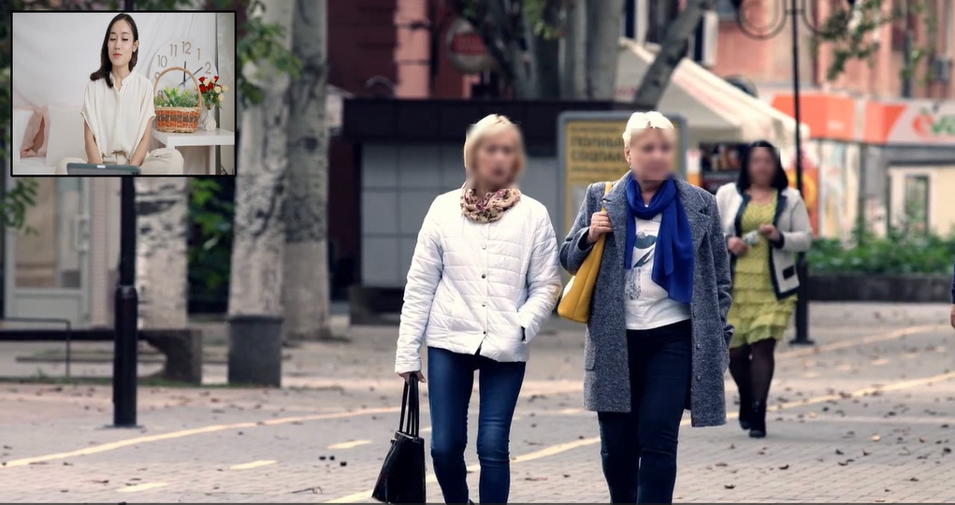

*Figure 10: Sample video output after overlaying videos*

***2.2.4 Results and discussion for add_watermark()***

The “add_watermark()” function is designed to apply watermarks to a video file using OpenCV. This function adds a dynamic watermark that alternates between two images at a specified boolean. Two watermark images, watermark1.png and watermark2.png, are loaded using ‘cv2.imread’. These images will be used as watermarks applied alternately to the video frames

*Watermark Alternation Logic:*

A boolean variable bool is initialized to control which watermark is currently active. It starts with True, indicating watermark1 is the initial watermark. The code iterates through every frame of the video using a for loop. The loop's range is based on the total frame count of the video (frameCount).

*Frame-Based Alternation:*

The watermark alternation is contingent on the frame count. At every 30-frame interval (which approximately translates to one second for a 30 FPS video), the bool variable is toggled. This action alternates the currentWatermark between watermark1 and watermark2.

*Frame Processing Loop:*

As the function processes each frame, it overlays the currentWatermark onto the frame using the ‘cv2.add’ function. This effectively superimposes the watermark image onto the video frame.Subsequently, each watermarked frame is written into the output video file through ‘out.write’.

*Sample Video Output –*

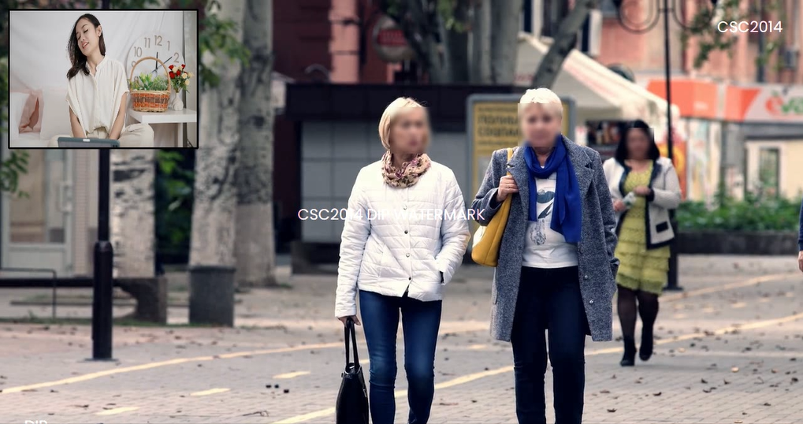

*Figure 12: Sample video output after adding watermarks*

***2.2.5 Results and discussion for add_endscreen()***

The ‘add_endscreen’ function orchestrates the process of seamlessly integrating an end screen video with a final video, resulting in a cohesive composite video with a designated output name.

*Appending Frames:*

The heart of the function lies in the appending process. It utilizes two separate loops to handle frames from the final video and the end screen video independently. The first loop iterates over the frames of the final video, reading each frame and writing it to the output video.Subsequently, the second loop handles the frames from the end screen video in a similar manner, ensuring that every frame from this video is appended to the output video:

*Sample Video Output –*

**

*Figure 15: Sample video output after adding endscreen*

**3.0 TASK B – PARAGRAPHS EXTRACTION**

This section report outlines an automated method for extracting paragraphs from document images with varying layouts including single-column, double-column, and multi-column text. The process utilizes OpenCV, an open-source computer vision library. The method is designed to handle complex document structures by employing image processing techniques such as grayscale conversion, thresholding, dilation, contour detection, and sorting.

***3.1 Methodology***

1. Convert the image to grayscale.
2. Apply adaptive thresholding to the image at (1).
3. Perform dilation to reduce small gaps in the text.
4. Detect the contours and then sort the detected text blocks.
5. Crop and save the paragraphs.

***3.2 Results & Discussion***

1. *Grayscale Conversion:* The conversion to grayscale was performed using ‘cv2.cvtColor(image, cv2.COLOR_BGR2GRAY)’, which effectively prepared the images for thresholding by reducing dimensionality and noise.

The initial step involves converting the RGB color image to a grayscale image. This is essential for reducing computational complexity and improving the performance of subsequent operations.

1. *Adaptive Thresholding:* Otsu's method is applied to determine an optimal threshold value automatically, which is particularly useful for images with variable lighting conditions. This is done using cv2.THRESH_BINARY_INV + cv2.THRESH_OTSU which inverts the thresholded result, making the text white on a black background.

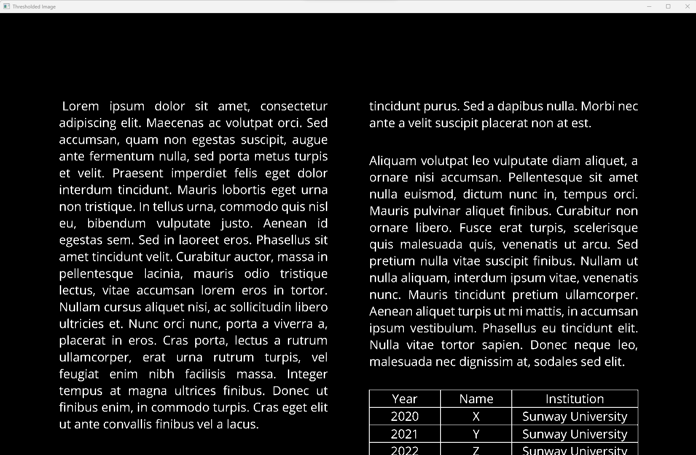

*Figure 20: Output image after adaptive thresholding*

1. *Dilation:* The dilation operation, cv2.dilate(th, rect_kernel, iterations=1), successfully connected text elements. This was crucial for the subsequent contour detection. This is applied to close the gaps within text elements, ensuring that each paragraph is detected as a single contour.

Dilation is used to bridge small gaps in the text, which is necessary for better contour detection. The kernel size and the number of iterations are chosen based on the average text size and spacing in the document.

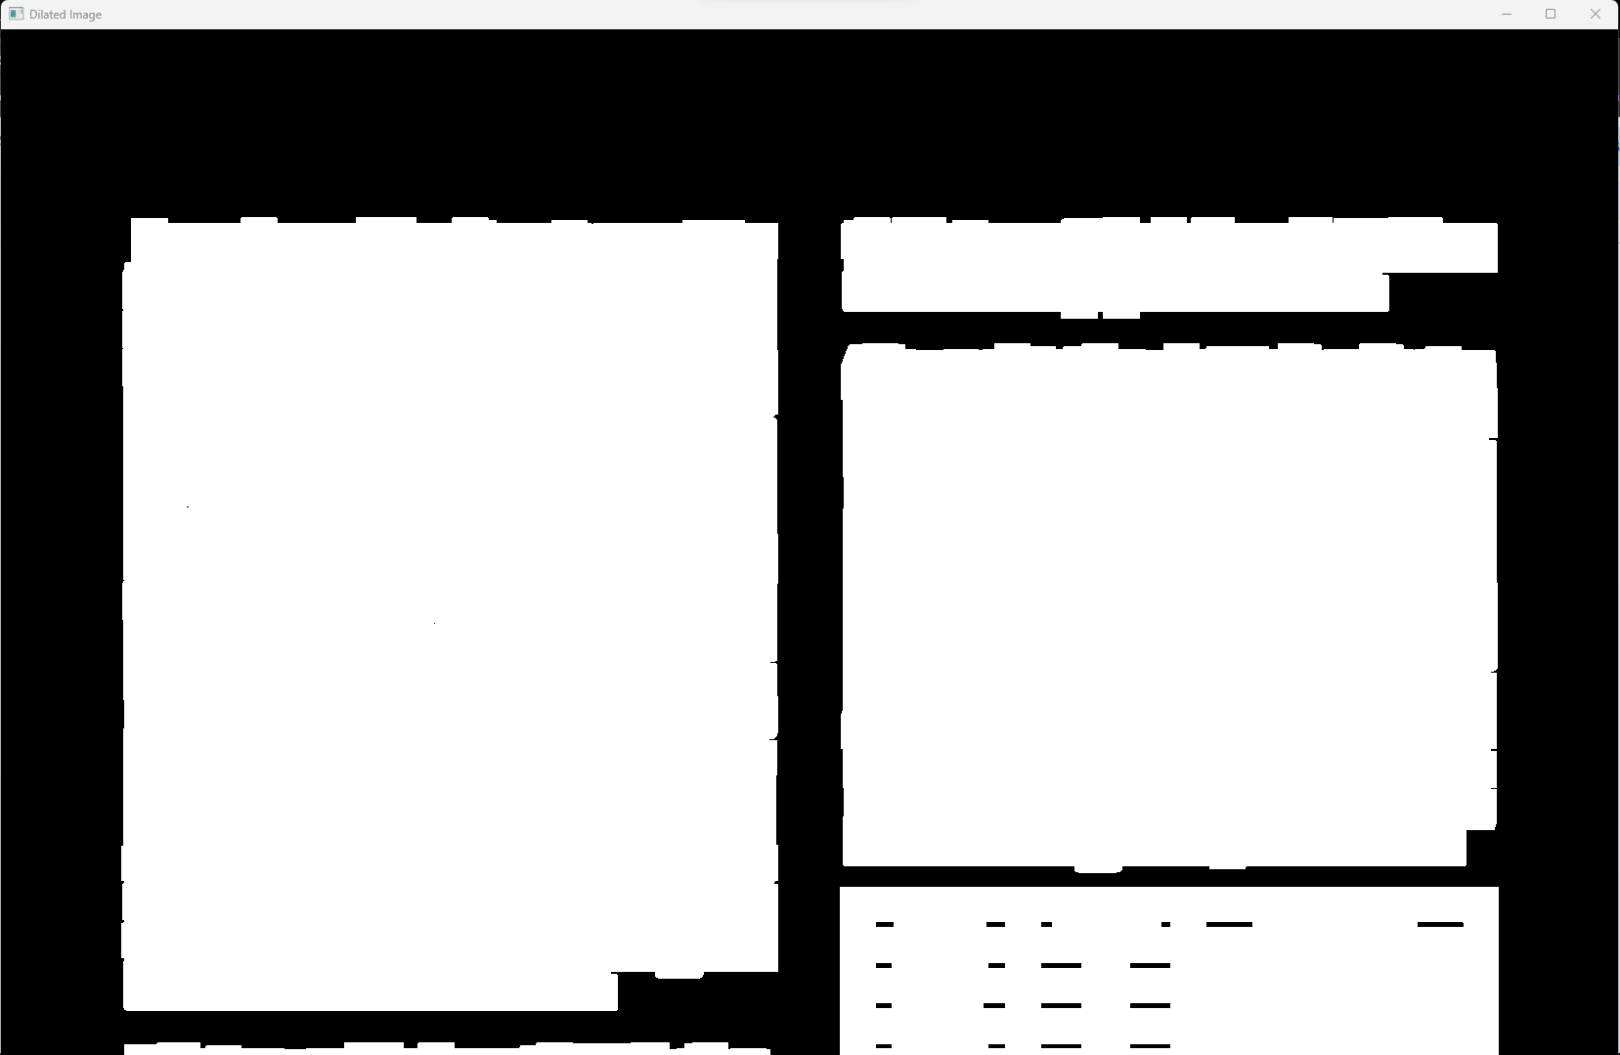

*Figure 22: Sample of a dilated image.*

1. *Contour Detection and Sorting:* Contour detection with ‘cv2.findContours(dilation, cv2.RETR_EXTERNAL, cv2.CHAIN_APPROX_NONE)’ followed by sorting with a custom function sort_contours correctly organizing the detected text blocks to reflect the document's natural reading order and match the sample output layout.

Contours are detected in the binary image, and a custom sorting algorithm is applied. This algorithm sorts contours first by their x-coordinate to identify columns and then by y-coordinate to ensure a top-to-bottom reading order within each column.

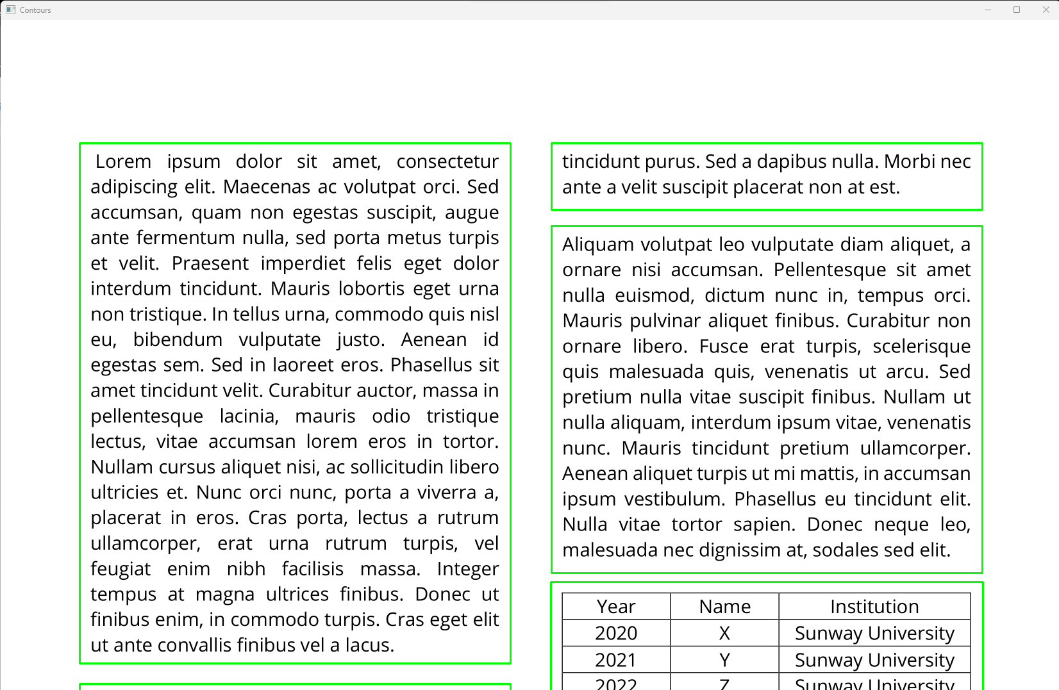

*Figure 24: Sample output after contour detection*

1. *Cropping and Saving Paragraphs:* The final paragraphs were cropped from the original image using ‘cv2.boundingRect(cnt)’ within the sorted contours loop and saved as individual image files, which matched the original document's layout and content.

The justifications for the coding decisions are:

The cv2.threshold with ‘cv2.THRESH_OTSU’ was selected for its automatic calculation of the optimum threshold value, which was evident in the binary images produced for different documents.

The choice of a rectangular kernel in the ‘cv2.getStructuringElement’ function matches the typically rectangular shape of paragraphs.

The ‘cv2.dilate’ function's effectiveness in merging text elements into clear blocks was visually confirmed, justifying its use before contour detection.

The implementation of the custom sort_contours function was justified as it allowed for the precise ordering of text blocks, ensuring that the extraction process respected the document's layout. The results were visually verified and checked with the provided sample output, showing the importance of this step.